<https://nethramysooru.wordpress.com/2014/01/09/xsd-import-include-and-redefine/>

I have demonstrated each type of import using few schemas starting with the XSD:Import type.

**XSD:Import**

In order to import an external schema we need use the “Imports” property available in schema properties window as below:

[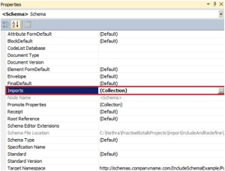](https://nethramysooru.files.wordpress.com/2014/01/17.jpg)

Fig: 1

Click the ellipsis button next to “(Collections)”. This will open up the Imports dialog box as shown:

[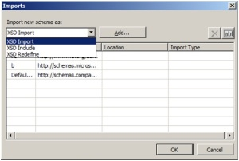](https://nethramysooru.files.wordpress.com/2014/01/21.jpg)

Fig: 2

Select “XSD:Import” and Click on the “Add” button which opens up the “BizTalk Type Picker” dialogue box. Select the schema you want to import:

[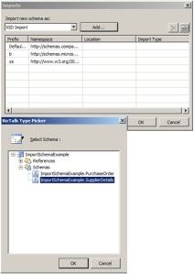](https://nethramysooru.files.wordpress.com/2014/01/31.jpg)

Fig: 3

The imported schema will be visible in the “Imports” dialogue box:

[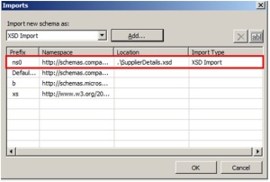](https://nethramysooru.files.wordpress.com/2014/01/41.jpg)

Fig: 4

Once the schema is referenced, you will be able to select the imported schema types from the “Data Structure Type” property for implementing in the Child Records. In the below example, I have imported “SuppliersDetails” schema into “PurchaseOrder” schema.  After importing I am defining “Suppliers” Record as “SupplierDetails” type.

[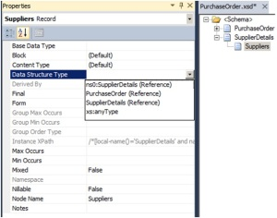](https://nethramysooru.files.wordpress.com/2014/01/51.jpg)

Fig: 5

**XSD:Include**

Follow the similar steps as above for XSD:Include option as shown:

[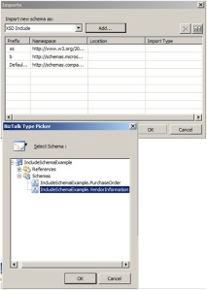](https://nethramysooru.files.wordpress.com/2014/01/61.jpg)

Fig: 6

[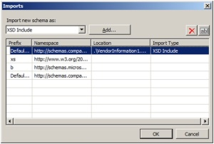](https://nethramysooru.files.wordpress.com/2014/01/71.jpg)

Fig: 7

In this example, I have included “VendorDetails” in the “PurchaseOrder” schema

[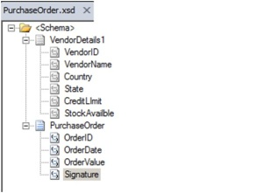](https://nethramysooru.files.wordpress.com/2014/01/81.jpg)

Fig: 8

**XSD:Redefine**

Follow the similar steps as above for XSD:Redefine option as shown:

[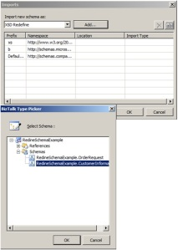](https://nethramysooru.files.wordpress.com/2014/01/91.jpg)

Fig: 9

**Note:** You will get the below error message if you attempt to “Include” or “Redefine” a schema with different namespace

[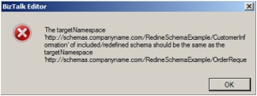](https://nethramysooru.files.wordpress.com/2014/01/101.jpg)

Fig: 10

[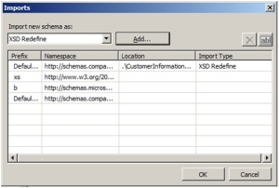](https://nethramysooru.files.wordpress.com/2014/01/111.jpg)

Fig: 11

As mentioned before, we have to use xml (text) Editor to redefine a schema since we cannot define directly in BizTalk Editor

[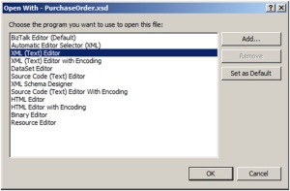](https://nethramysooru.files.wordpress.com/2014/01/121.jpg)

Fig: 12

In this Demo, PurchaseOrder schema redefines the CustomerInformation schema.

In the customerInformation schema I have defined a complexType as “CustomerInformationType” and CustomerInfomation element uses this type

[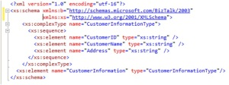](https://nethramysooru.files.wordpress.com/2014/01/131.jpg)

Fig: 13

[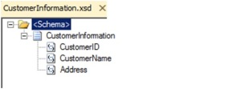](https://nethramysooru.files.wordpress.com/2014/01/141.jpg)

Fig: 14

In the “PurchaseOrder” schema, I am redefining the “CutomerInformationType” by adding an additional element “Country” to it

[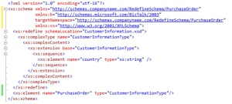](https://nethramysooru.files.wordpress.com/2014/01/151.jpg)

Fig: 15

[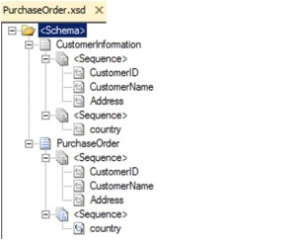](https://nethramysooru.files.wordpress.com/2014/01/161.jpg)

Fig: 16

References:

[http://msdn.microsoft.com/en-us/library/ee254473(v=bts.10).aspx](https://nethramysooru.wordpress.com/Nethra/BiztalkBlogDocs/References.txt)

[http://www.w3schools.com/schema/el_redefine.asp](https://nethramysooru.wordpress.com/Nethra/BiztalkBlogDocs/References.txt)